SDC ŠUMAVÁČEK

CLUB EVENING 10.7.2025

before advanced weekend with David Dvořák (11.-13.7)

Loučovice - kulturní dům

GPS 48.6214572N, 14.2566894E

+ A1

Caller: Míra Procházka

Please, before visit send email on prochna@centrum.cz

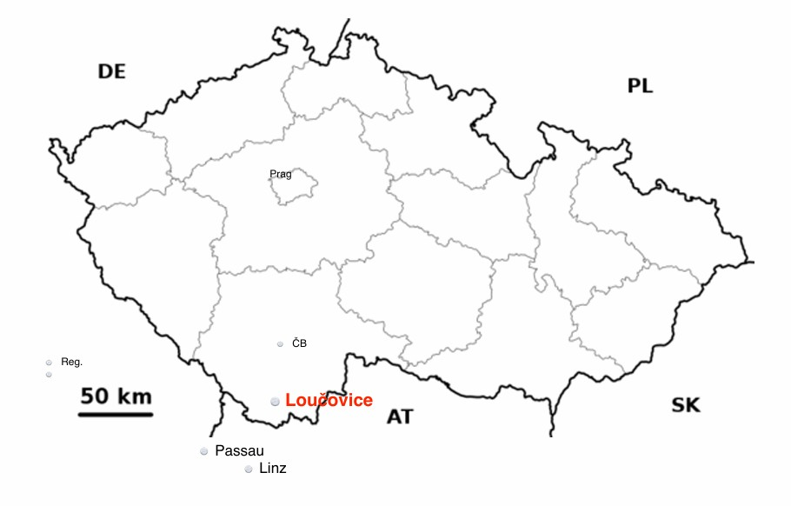

www.sumavacek.cz