**SDC Šumaváček**

# Invited you on weekend with old time dance (contra, big circles, traditional squares)

# 20.-22.6.2025

# Place: Plovárna, Stříbský mlýn 5, Ivančice Czech republic

## GPS 49.0886375N, 16.4074928E

## Caller: Miroslav Procházka

**Badge 950,- Kč or 38 Euro**

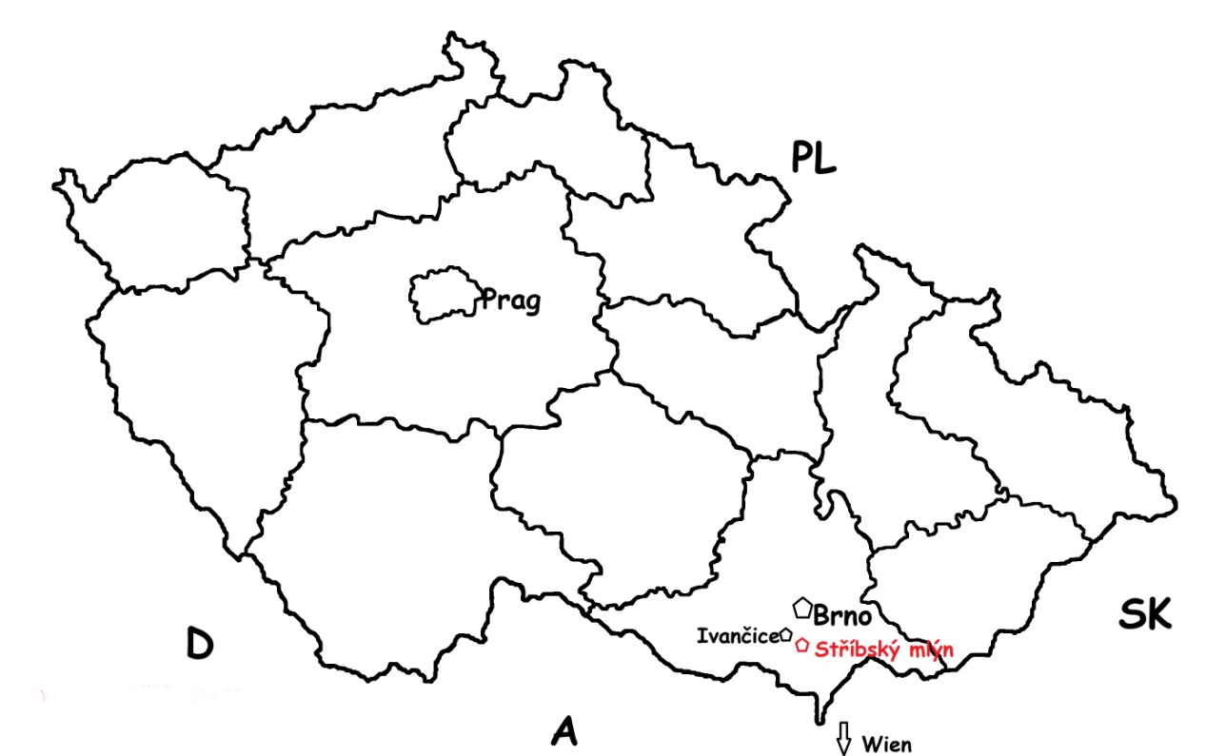

Accomodation: In many pensions or camping place in the vicinity.

**Programm**

Friday :

17.00 – 20.00 – Registration

19.00 – 22.00 – Dancing

*Out of program 22.00- 24.00 – Free dancing (afterparty)*

Saturday :

9.00 – 11.50 – Dancing

14.30 – 17.30 – Dancing

19.00 – 21.30 – Dancing

*Out of program 22.00- 24.00 – Free dancing (afterparty)*

Sunday:

9.00 – 10.30 – Dancing

**Contact: Míra Procházka, Loučovice 276, 382 76 Czech Republic**

**email [prochna@centrum.cz](mailto:prochna@centrum.cz)**

**Please, if You wont visit this weekend, send email for pre-registration. Thank You!**

[**www.sumavacek.cz**](http://www.sumavacek.cz)